Sales

# ERD for UX process

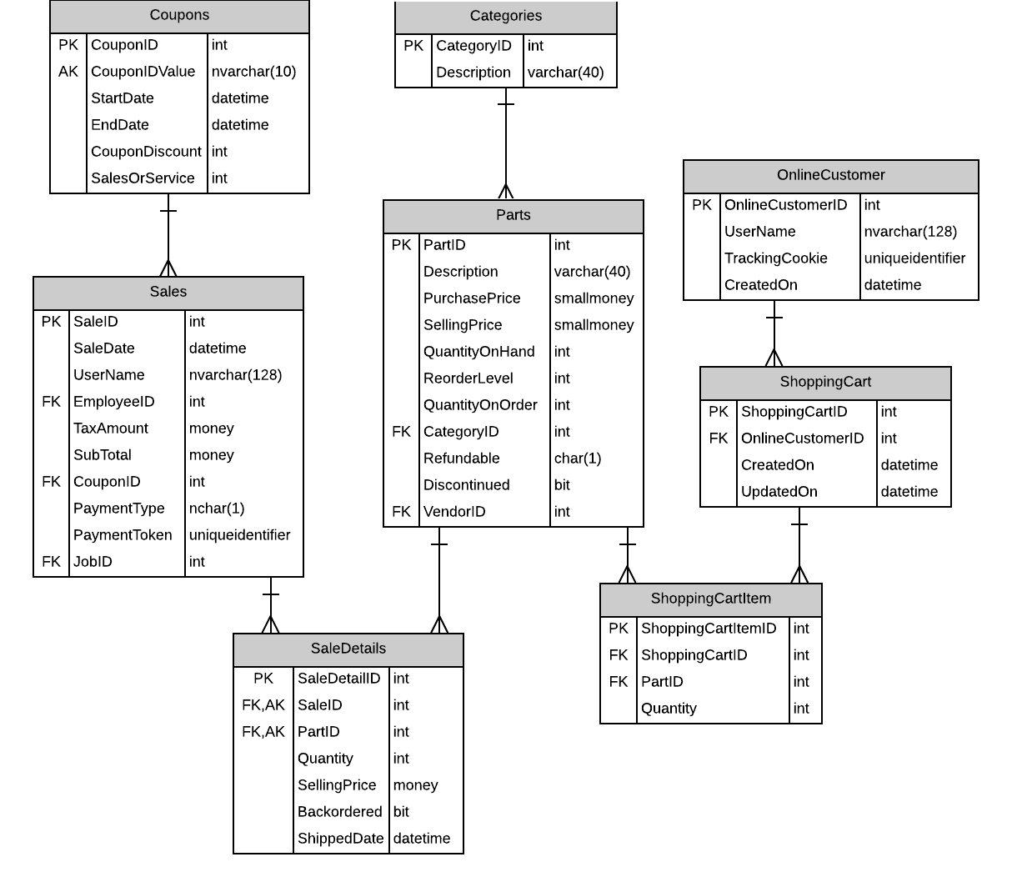

# Possible UX Interface

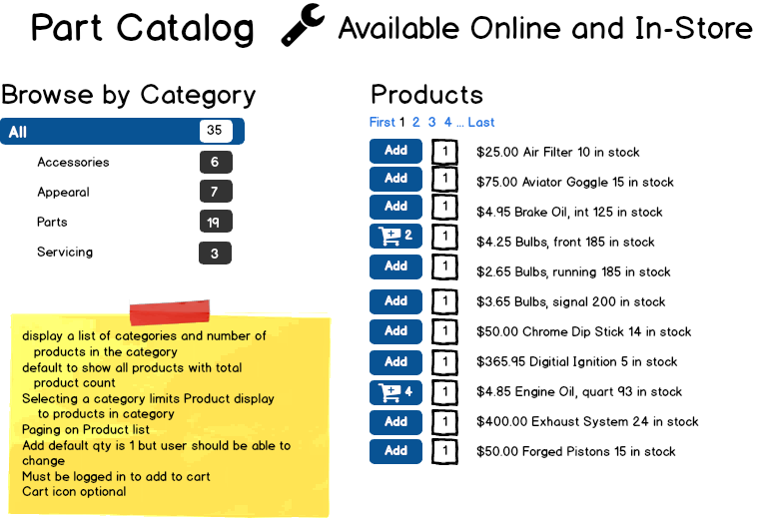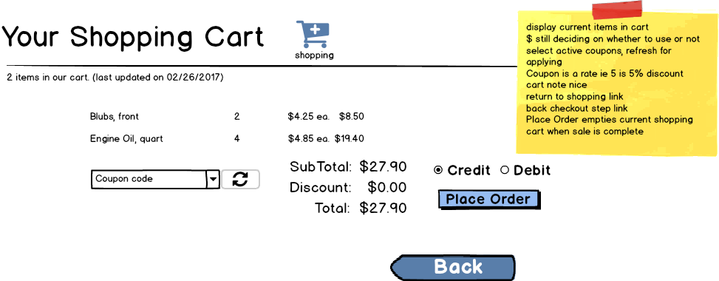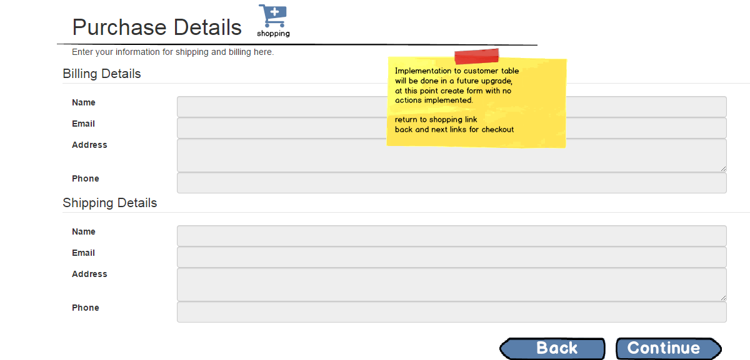

# Event and Wiring Summations

|  |  |  |
| --- | --- | --- |
| **Controls** | | **Events** |
| CategoriesList | | None / wired via ObjectDataSource |
| **BBL Class(es) and Method (s)** | | |
| CategoriesController | List<Categories> GetCategories()  Return a list of all categories (id, name, and count of parts). | |
| **SQL Table(s): (C,R,U,D)** | | **Entities/DTOs/POCOs** |
| Categories, Parts (R) | | OnlineCategories (P) |

|  |  |  |
| --- | --- | --- |
| **Controls** | | **Events** |
| CategoriesList, PartsList | | None / wired via ObjectDataSource |
| **BBL Class(es) and Method (s)** | | |
| PartsController | List<OnlineParts> GetParts(int categoryId)  Returns a list of all of the parts in the category. | |
| **SQL Table(s): (C,R,U,D)** | | **Entities/DTOs/POCOs** |
| Parts (R) | | OnlineParts (P) |

|  |  |  |
| --- | --- | --- |
| **Controls** | | **Events** |
| AddItemButton, AddItemQuantity | | AddItemClicked |
| **BBL Class(es) and Method (s)** | | |
| ShoppingCartController | Void AddToCart(IPrincipal user, int partId, int quantity)  Add an item to the user’s cart (creating their cart if not present) if,   1. The user is logged in, 2. The part is not discontinued, 3. And the user is not logged in as an employee.   If any of these conditions do not apply, an error will be thrown. | |
| **SQL Table(s): (C,R,U,D)** | | **Entities/DTOs/POCOs** |
| ShoppingCart (C,R,U), ShoppingCartItem (C) | | OnlineShoppingCartItem |

|  |  |  |
| --- | --- | --- |
| **Controls** | | **Events** |
| PartsList | | None / wired via ObjectDataSource |
| **BBL Class(es) and Method (s)** | | |
| ShoppingCartController | OnlineShoppingCart GetShoppingCart(IPrincipal user)  Gets the user’s shopping cart (or null if the user does not have one). | |
| **SQL Table(s): (C,R,U,D)** | | **Entities/DTOs/POCOs** |
| ShoppingCart (R) | | OnlineShoppingCart (D) |

|  |  |  |
| --- | --- | --- |
| **Controls** | | **Events** |
| AddItemQuantity, AddItemButton, UpdateItemButton | |  |
| **BBL Class(es) and Method (s)** | | |
| ShoppingCartItemController | Void ChangeShoppingCartItemQuantity(int shoppingCartItemId, int quantity)  Changes the quantity of shopping cart items. If the quantity is being set to 0, the item will be removed. | |
| **SQL Table(s): (C,R,U,D)** | | **Entities/DTOs/POCOs** |
| ShoppingCartItem (U,D) | | ShoppingCartItem |

|  |  |  |
| --- | --- | --- |
| **Controls** | | **Events** |
|  | |  |
| **BBL Class(es) and Method (s)** | | |
|  | Void PlaceOnlineOrder(int shoppingCartId, PaymentType paymentType, int couponId) | |
| **SQL Table(s): (C,R,U,D)** | | **Entities/DTOs/POCOs** |
|  | |  |

|  |  |  |
| --- | --- | --- |
| **Controls** | | **Events** |
|  | |  |
| **BBL Class(es) and Method (s)** | | |
|  | Int GetShoppingCartItemCount(IPrincipal user) | |
| **SQL Table(s): (C,R,U,D)** | | **Entities/DTOs/POCOs** |
|  | |  |